

**PREFACE**

This project “My Portfolio” welcome to my personal  
portfolio website project! As you journey through  
these digital corridors, you'll embark on an exploration  
of my professional endeavors, creative passions, and  
technological innovations. Crafting this digital space  
has been a labor of love, a convergence of my skills,  
experiences, and aspirations. In an era where the  
digital realm serves as the primary gateway to one's  
professional identity, a well-crafted portfolio website is  
more than just a collection of projects; it's a testament  
to one's capabilities, creativity, and commitment to  
excellence

**DECLARATION**

I hereby declare that this project report entitled  
“**Personal Portfolio website**” submitting by me for the  
partial fulfilment of the requirement for the award of  
Bachelor in Computer Application (BCA) is an authentic  
work completed by Anmol Singh. The report being  
submitted has not been submitted earlier for the  
award of degree or diploma to our institute.

Date:

Signature:  
Name: Anmol Singh

**CERTIFICATE**

This is certified that ANMOL SINGH student of BCA  
(VI semester) of MANORAMA Institute OfManagement & Technology, has successfully  
completed the project work entitled “personalportfolio website” under the guidance of prof. HARSHSHARMA is a bonafide piece of work carried out at  
Manorama institute of management & technology.

The project entitled “E-commerce shopping website”  
developed by ANMOL SINGH in the Manorama  
institute of management & technology and he/she had  
done his/her laboratory work during the tenure of the  
project with the guide to complete the project. All the  
prescribed certificates are attached after the  
completion of all the formalities of the paper work as  
per schedule, including examination.

**Place: Agra** Signature:

**Acknowledgment**

Firstly we would like to express our gratitude to our  
guide MR. Harsh Sharma sir & other faculty member  
for giving us wonderful opportunity to work on the  
project.

Embarking on the journey of creating my personal  
portfolio website has been a fulfilling endeavor, made  
possible through the support, guidance, and  
encouragement of many individuals whom I deeply  
appreciate. This portfolio website is a reflection of the  
collective efforts, support. We are also thankful to all  
my teachers of MANORAMA INSTITUTE OFMANAGEMENT & TECHNOLOGY. And in the end, we  
would like to thank all those who helped me during this  
project

Signature: **Anmol Singh**

**INTRODUCTION**

In an age dominated by digital interactions, a personal  
portfolio website stands as a quintessential tool for  
professionals across diverse fields. It serves as a virtual  
storefront, offering a glimpse into one's skills,  
experiences, and achievements. This report delves into  
the creation and significance of my personal portfolio  
website, elucidating the rationale behind its  
development, the methodologies employed, and the  
overarching goals driving its design and content.

In an age dominated by digital interactions, a personal  
portfolio website stands as a quintessential tool for  
professionals across diverse fields. It serves as a virtual  
storefront, offering a glimpse into one's skills,  
experiences, and achievements. This report delves into  
the creation and significance of my personal portfolio  
website, elucidating the rationale behind its  
development, the methodologies employed, and the  
overarching goals driving its design and content. elucidating the primary motivations behind the  
creation of the website. Subsequently, it delves into  
the methodologies employed in designing and  
developing the website, encompassing aspects such as  
conceptualization, design principles, technological  
frameworks, and user experience considerations. the  
report explores the content strategy adopted for the  
portfolio website, detailing the selection, organization,  
and presentation of projects, achievements, and other  
pertinent information. Additionally, it discusses the  
technical intricacies involved in the development  
process, including coding languages, frameworks, and  
optimization techniques employed to ensure optimal  
performance and accessibility. this report serves as a  
testament to the meticulous planning, creative  
execution, and strategic vision that underpin the  
creation of my personal portfolio website. It is my hope  
that through sharing insights into this project, others  
may glean inspiration, guidance, and practical  
knowledge for their own endeavors in crafting a  
compelling digital presence.

**Scope of Project**

The scope of a personal portfolio website can vary  
depending on your goals, industry, and personal  
preferences, but here are some common elements you  
might consider including

**Homepage**: An introduction to who you are and  
what you do. This should provide a snapshot of your  
skills and expertise.

**About Me**: A section where you can provide a more  
detailed background about myself, my experiences,  
education, and career journey. This helps visitors get to  
know you better.

**Portfolio:** Showcase your work here. Include samples  
of projects, case studies, or links to articles you've  
written. This could include design projects, writing  
samples, code snippets, or any other work relevant to  
your field.

**Resume/CV:** Optionally, you can include a  
downloadable version of your resume or CV for visitors  
to review or print.

**Project Objectives**

**Showcase Skills and Expertise:** The primary objective  
of my personal portfolio is to showcase my skills,  
expertise, and accomplishments across various  
domains. By presenting a curated selection of projects,  
achievements, and experiences, the portfolio aims to  
demonstrate my capabilities and proficiency in my  
field(s) of interest.

**Establish Professional Identity:** Another key objective  
is to establish a strong and memorable professional  
identity. Through consistent branding, visual elements,  
and messaging, the portfolio seeks to convey a clear  
and cohesive image of who I am as a professional,  
what I stand for, and the value I bring to potential  
collaborators, employers, and clients.

**Establish Professional Identity:** Another key objective  
is to establish a strong and memorable professional  
identity. Through consistent branding, visual elements,  
and messaging, the portfolio seeks to convey a clear  
and cohesive image of who I am as a professional,  
what I stand for, and the value I bring to potential  
collaborators, employers, and clients.

**Adaptability and Growth:** Finally, the portfolio is  
designed to be adaptable and conducive to growth. As  
my skills, experiences, and interests evolve over time,  
the portfolio will continue to evolve accordingly,  
reflecting the latest developments, projects.

**Technology Used to Design Project**

**HTML:** HTML stands for Hyper Text Markup Language.  
It's the standard markup language for creating web  
pages and web applications. HTML describes the  
structure of a web page semantically and originally  
included cues for the appearance of the document.  
HTML elements are the building blocks of HTML pages,  
and they are represented by tags. These tags label  
pieces of content such as headings, paragraphs,  
images, links, and more. Web browsers use HTML to  
interpret and render the content of web pages for  
users.

**CSS:** CSS, or Cascading Style Sheets, is a style sheet  
language used to describe the presentation of a  
document written in HTML or XML (including XML  
dialects such as SVG, Math ML, etc.). CSS describes  
how elements should be rendered on screen, in print,  
or in other media.  
CSS separates the presentation style of a web page  
from its content, allowing developers to define styles  
such as layout, colors, fonts, and spacing  
independently of the HTML structure. This separation  
of concerns makes it easier to maintain and update the  
visual appearance of a website.

**JAVASCRIPT:** JavaScript (JS) is a high-level  
programming language that is commonly used to add  
interactivity and dynamic behavior to web pages. It  
was initially developed for use in web browsers, but it  
is now widely used for server-side development as  
well, thanks to frameworks like Node.js.  
JavaScript allows developers to manipulate the content  
and structure of web pages in real-time, enabling  
features such as form validation, animations,  
interactive maps, and much more. It is a versatile  
language that can be used for both client-side and  
server-side scripting.

**Software used to Design Website**

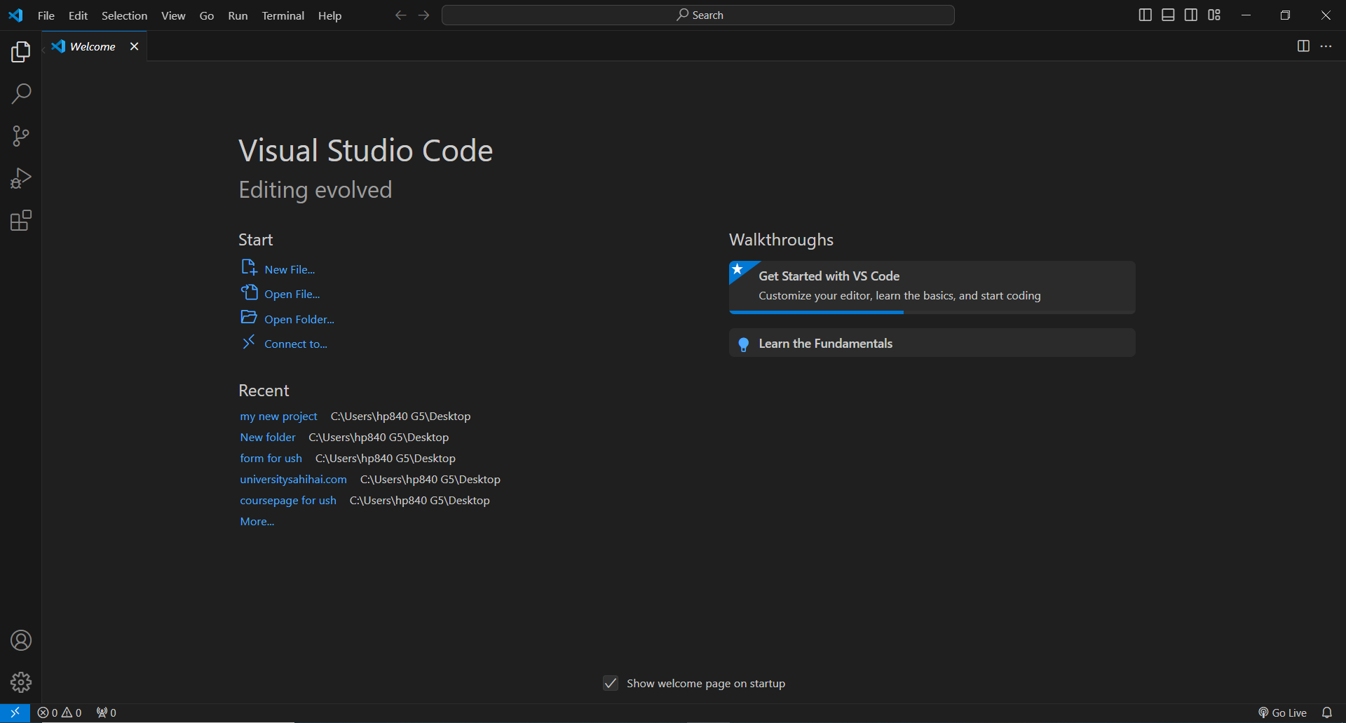

To design a website, you’ll need a combination of  
software tool for various tasks such as graphic design,  
coding, content management and more.  
The specific software you choose can depend on you  
skills, preferences, and the complexity of your  
project. Here is some essential type of software you  
might consider.

**VS CODE:** VS Code, short for Visual Studio Code, is a  
free source-code editor developed by Microsoft for  
Windows, Linux, and macOS. It's designed to be  
lightweight yet powerful, with features tailored for  
web development (HTML, CSS, JavaScript), but it  
supports a wide range of other programming  
languages through extensions.  
VS Code offers features like syntax highlighting,  
intelligent code completion, debugging support, Git  
integration, and customizable themes and extensions.  
It has gained significant popularity among developers  
due to its speed, ease of use, and extensive  
customization options. Additionally, it's highly  
extensible, allowing users to Visual Studio Code,  
commonly referred to as VS Code, is a lightweight yet  
powerful source code editor developed by Microsoft.  
Launched in 2015, it has quickly become one of the  
most popular code editors among developers due to its  
versatility, robust features, and extensive ecosystem of  
extensions. Here's a closer look at some key aspects of  
VS Code: Visual Studio Code has emerged as a versatile  
and indispensable tool for developers, offering a rich  
set of features, a vibrant ecosystem of extensions, and  
a seamless development experience across different  
platforms and programming languages. Its popularity  
continues to grow, cementing its position as one of the  
leading code editors in the industry.

**Project Layout**

|  |  |
| --- | --- |
| **Section** | **Description** |
| **Navbar** | Home, About, Skills, Certificate,  Projects, Contact, Footer |
| **Hero Section** | "title and goals and many more about me." |
| **About Section** | "Learn more about my journey, values, and commitment to excellence." |
| **Skill Section** | Skills like:-HTML,CSS,JS,FIGMA,CANVA |
| **Certificates** | My Achievements |
| **Projects Section** | My Projects |
| **Contact Section** | Contact Section to Connect people’s with Us |
| **Footer Section** | Copyright and contact icons. |

**Navbar**



Certainly! Here's a brief description of each element for your website:

**Logo of My Name**:

* **Design**: A stylized representation of my name, using a unique font or graphic elements that reflect my personal identity.
* **Placement**: Typically located at the top left corner of the website for instant brand recognition.

**Home**:

* **Content**: An introductory section that provides an overview of who you are and what the website is about.
* **Design**: Clean and inviting, often with a hero image or slider, and key information presented in a visually appealing way.

**About**:

* **Content**: Detailed information about you, your background, mission, and values.
* **Design**: A mix of text and images, possibly with a timeline or story format to make it engaging.

**Skills**:

* **Content**: A list or showcase of your professional skills and expertise.
* **Design**: Could include icons, progress bars, or graphs to visually represent your skill levels.

**Certificate**:

* **Content**: Displays your certifications and achievements.
* **Design**: Thumbnails of certificates or badges, with brief descriptions or titles for each.

**Projects**:

* **Content**: A portfolio of your work or projects you have completed.
* **Design**: Grid or gallery layout with images, descriptions, and links to detailed project pages or case studies.

**Contact Us**:

* **Content**: A section where visitors can get in touch with you, including a contact form, email address, and possibly phone number and physical address.
* **Design**: Simple and straightforward, often with a map if relevant, and social media links.

Each of these elements should be cohesively designed to create a seamless user experience that aligns with my personal identity.

**Home**

This hero section provides a warm welcome and immediate introduction to visitors, with a clear visual of who you are.

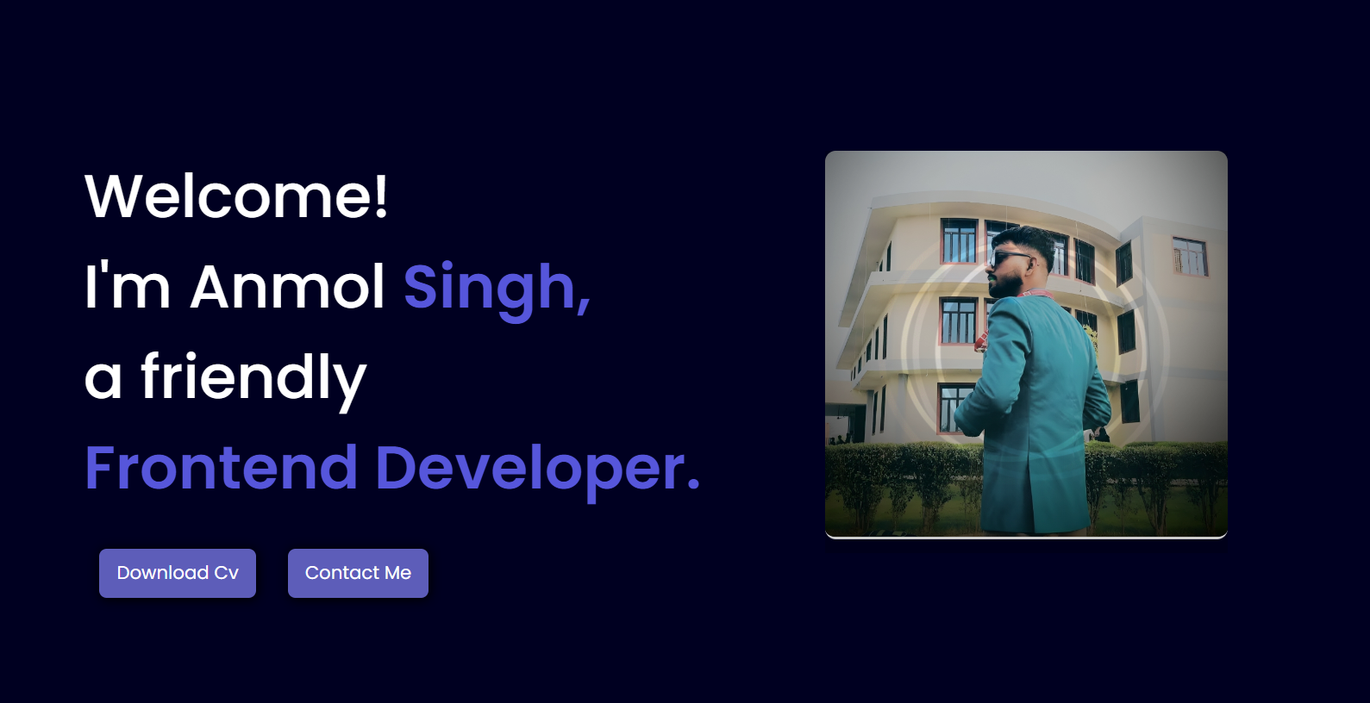

**Hero Section**:

* **Welcome Message**: A friendly greeting such as "Welcome to My Website!"
* **Title**: A brief introduction, e.g., "Hi, I’m [Anmol Singh], [Frontend Developer]”.
* **Image of You**: A professional, high-quality photo of myself.

This hero section provides a warm welcome and immediate introduction to visitors, with a clear visual of who you are.

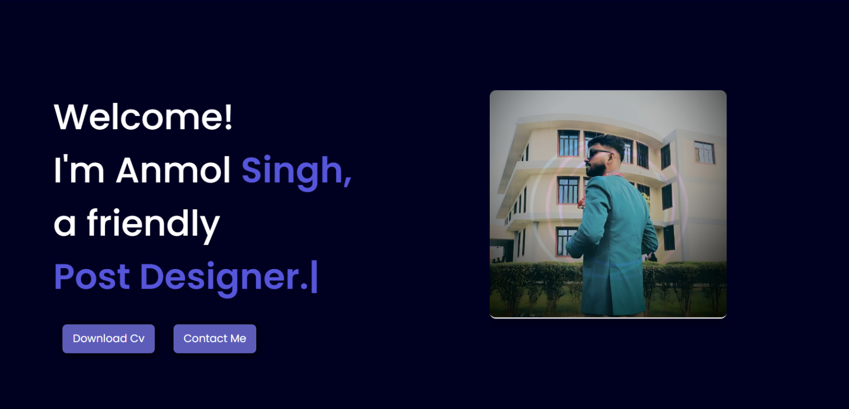

**Hero Section**:

* **Welcome Message**: A friendly greeting such as "Welcome to My Website!"
* **Title**: A brief introduction, e.g., "Hi, I’m [Anmol Singh], [Post designer]"
* **Image of You**: A professional, high-quality photo of myself.

This hero section provides a warm welcome and immediate introduction to visitors, with a clear visual of who you are.

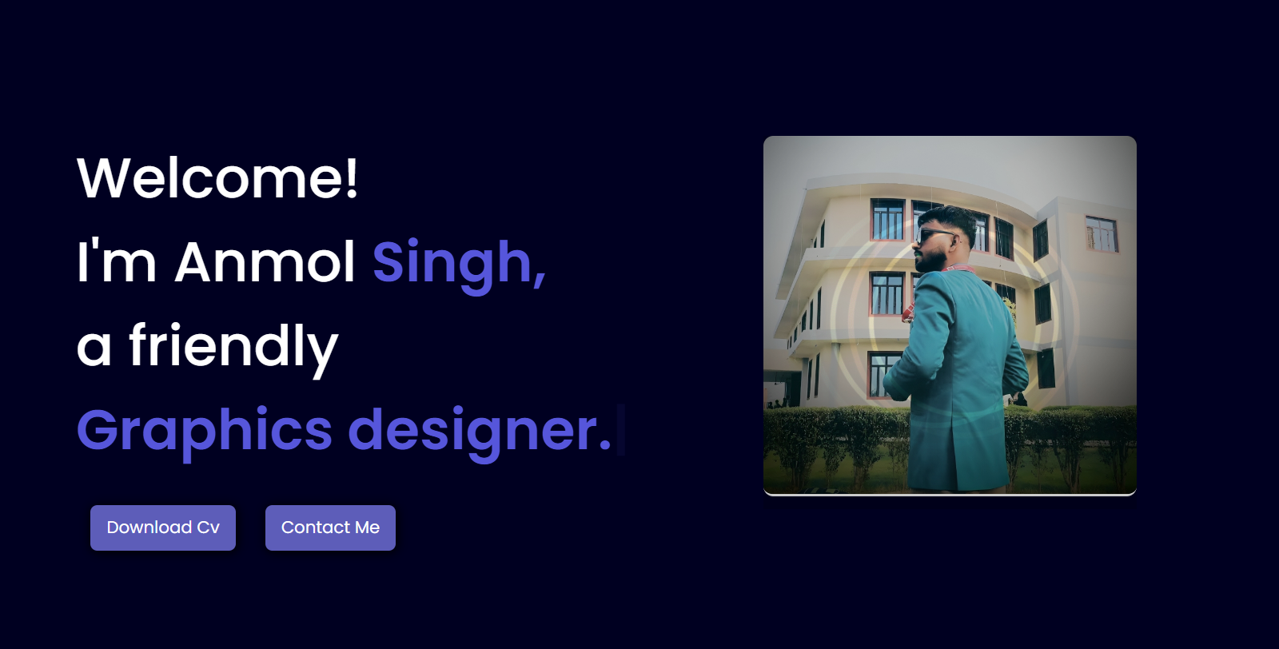

**Hero Section**:

* **Welcome Message**: A friendly greeting such as "Welcome to My Website!"
* **Title**: A brief introduction, e.g., "Hi, I’m [Anmol Singh], [Graphic designer]"
* **Image of You**: A professional, high-quality photo of myself.

**Also Have Two Buttons:**

1. **CV Button**:
   * **Text**: "Download CV"
   * **Purpose**: Allows visitors to download your resume or CV.
2. **Contact Me Button**:
   * **Text**: "Contact Me"
   * **Purpose**: Directs visitors to your contact form or contact information.

**About**

This About Section effectively communicates my professional identity, background, and what motivates me, helping visitors connect with me on a personal and professional level.

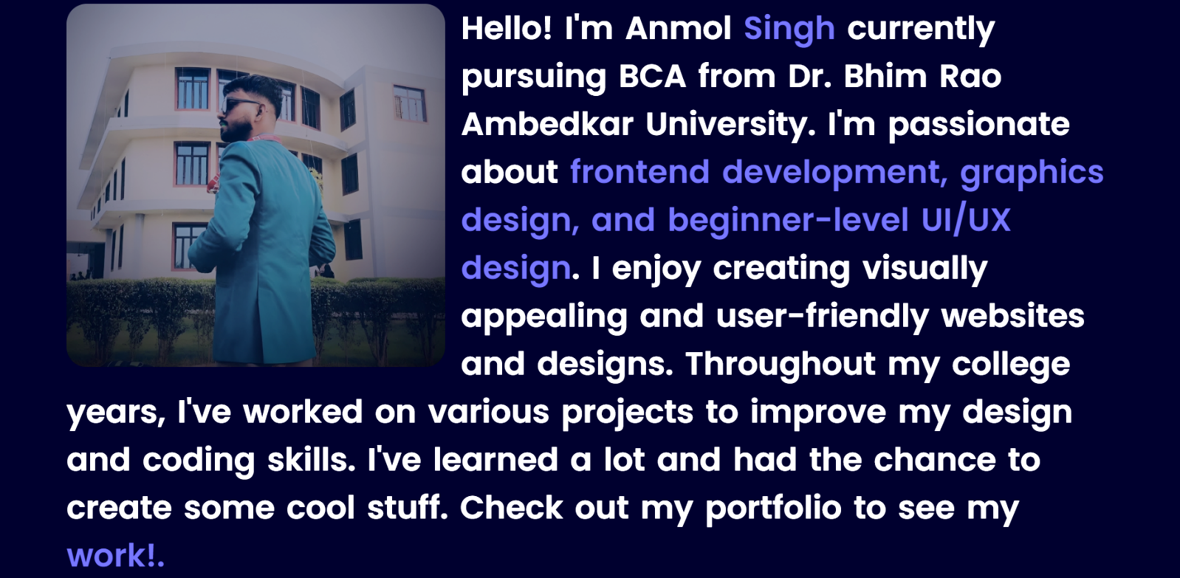

Brief overview of your background, including your college name and passion.

**Skills**

Explore my professional skills and expertise that I bring to every project.

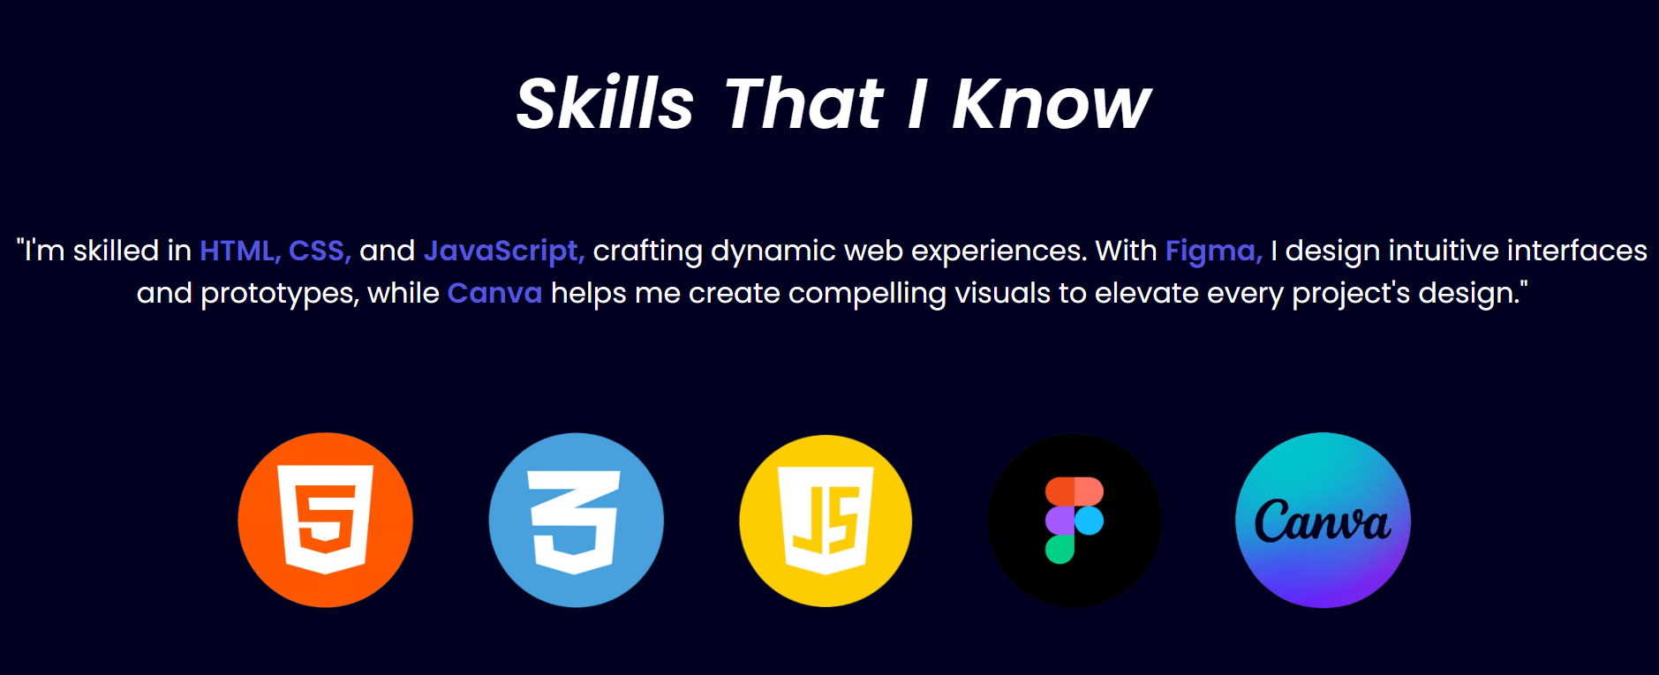

I'm skilled in HTML, CSS, and JavaScript, crafting dynamic web experiences. With Figma, I design intuitive interfaces and prototypes, while Canva helps me create compelling visuals to elevate every project's design.

**Here are brief descriptions for each skill:**

1. **HTML:**
   * **Description**: The standard markup language for creating web pages. It structures content on the web.
2. **CSS:**
   * **Description**: A stylesheet language used to describe the presentation of a document written in HTML. It styles the visual layout of web pages.
3. **JavaScript:**
   * **Description**: A programming language that enables interactive web pages. It adds dynamic behavior to websites.
4. **Figma:**
   * **Description**: A web-based design tool for creating user interfaces and prototypes. It supports collaborative design workflows.
5. **Canva:**
   * **Description**: An online graphic design platform used to create social media graphics, presentations, posters, and other visual content. It offers an easy-to-use interface and a variety of templates.

**Achievements**

Highlighting my notable accomplishments and milestones throughout my career journey.

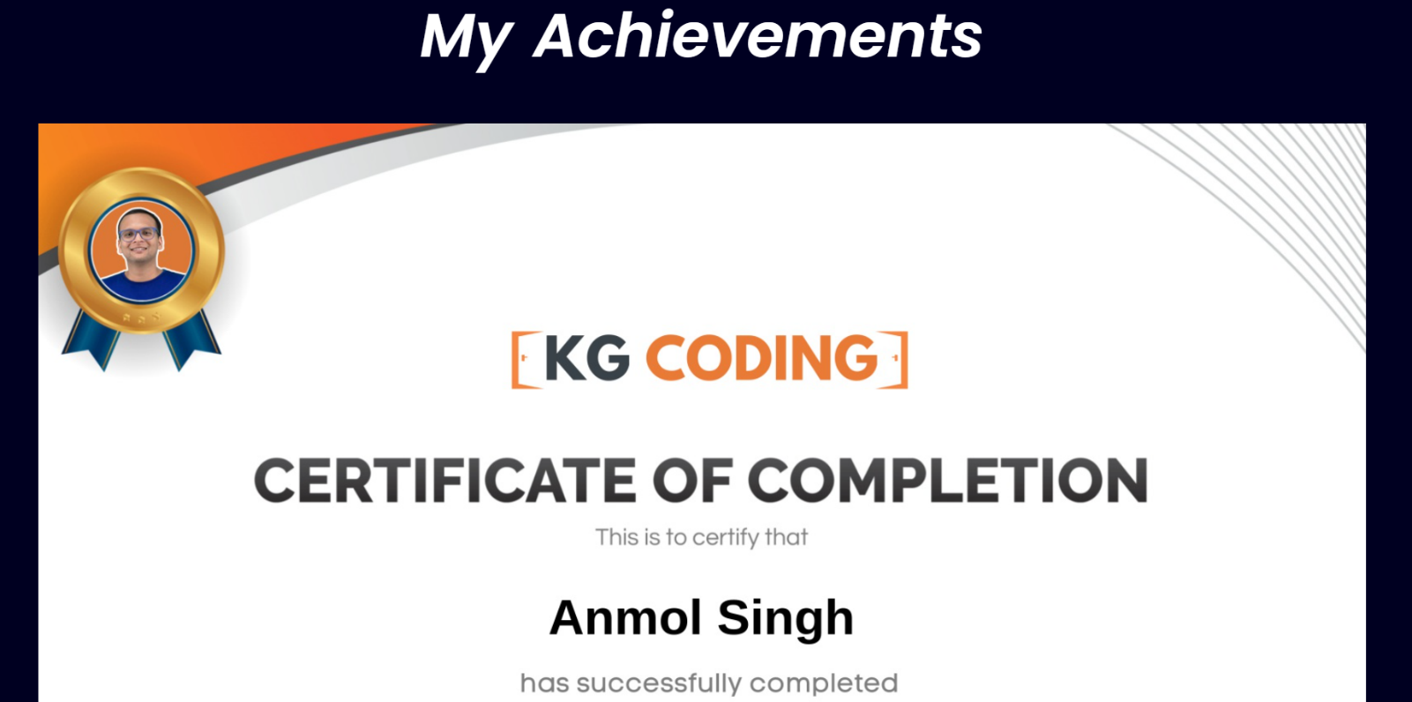

In the Achievements section, I showcase my notable accomplishments and milestones, demonstrating my dedication, expertise, and impact in various areas of my profession.

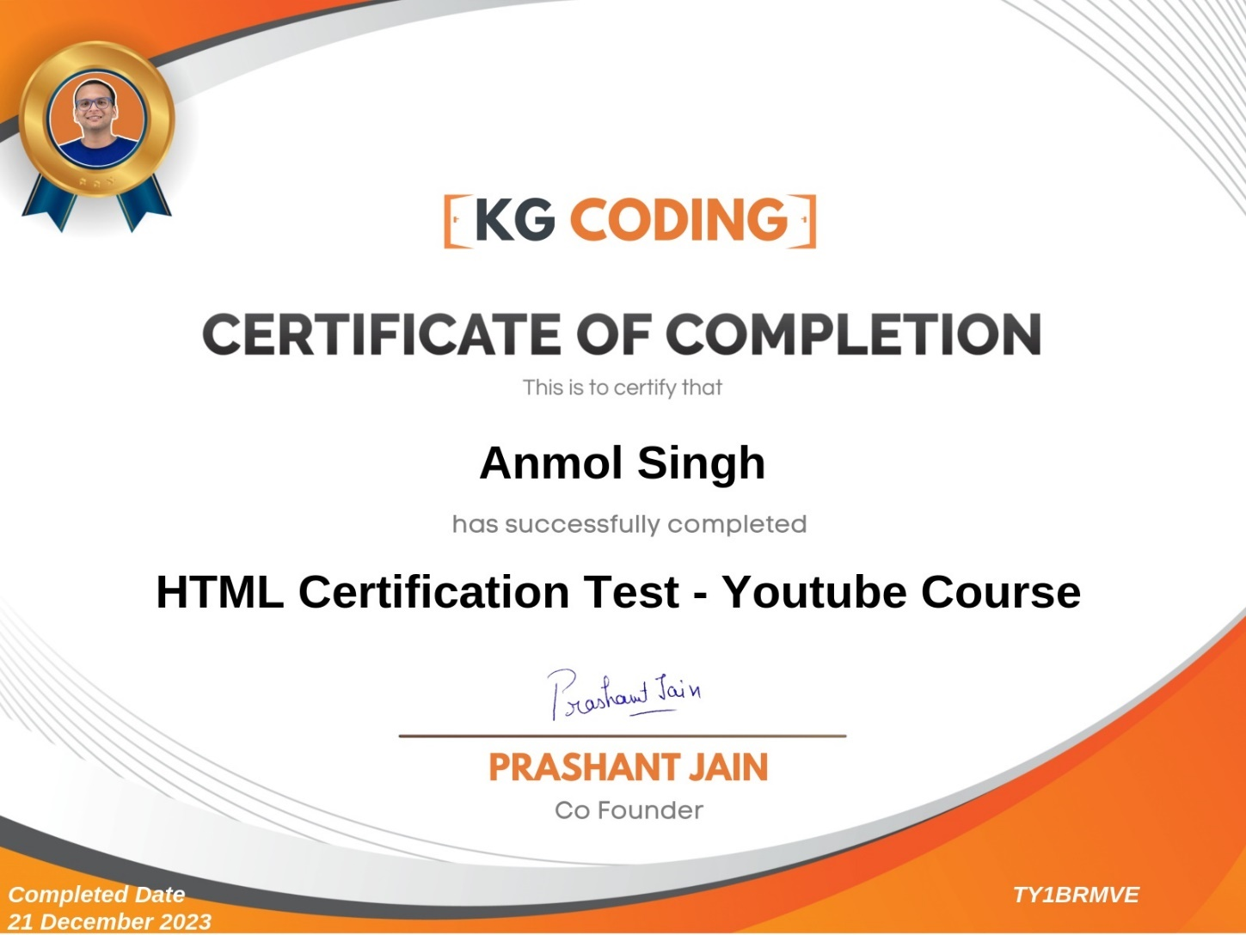

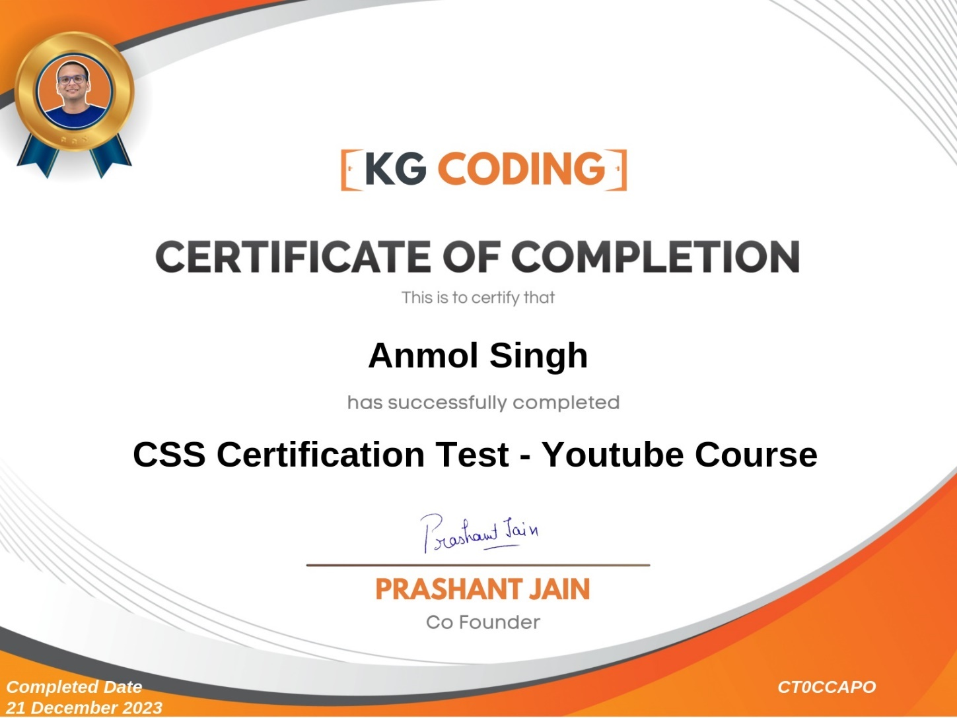





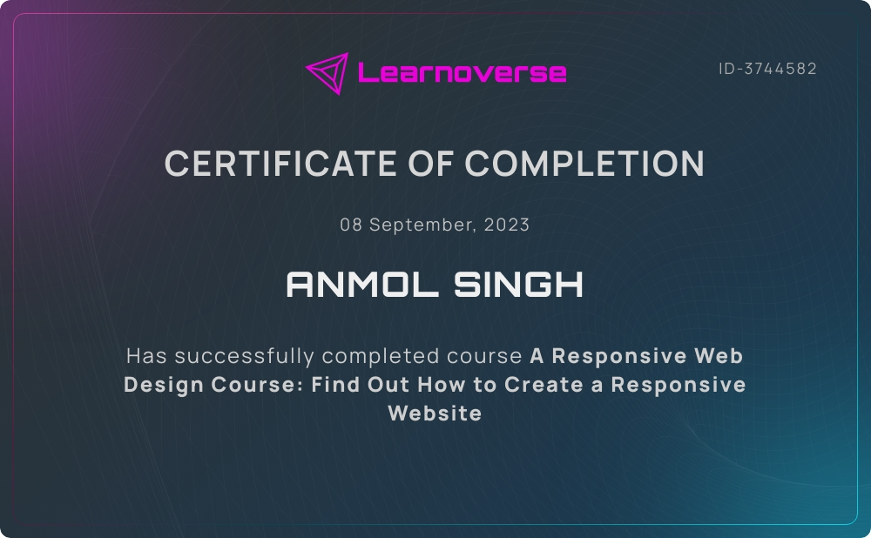

In the Certificates section, I proudly display my recognized achievements and certifications, showcasing my commitment to continuous learning and expertise in various domains.

**Projects** (Designs)

In this Design section, I present a diverse range of creative works crafted for practice, showcasing my creativity, problem-solving skills, and dedication to honing my craft. Each design represents an opportunity for growth and learning, illustrating my evolving abilities and passion for design development.

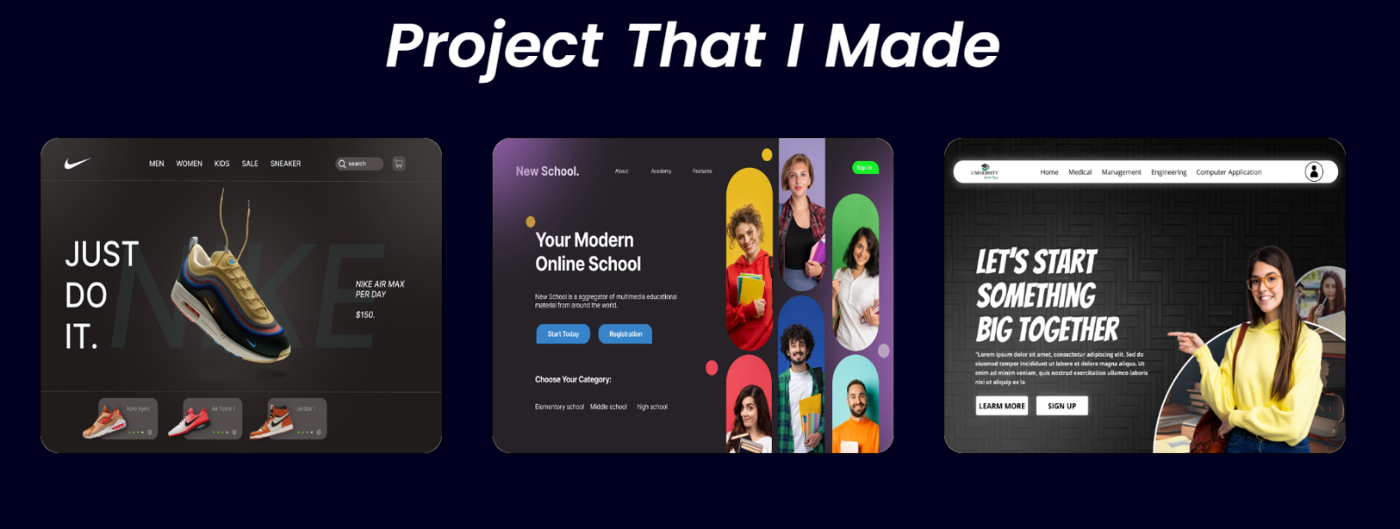

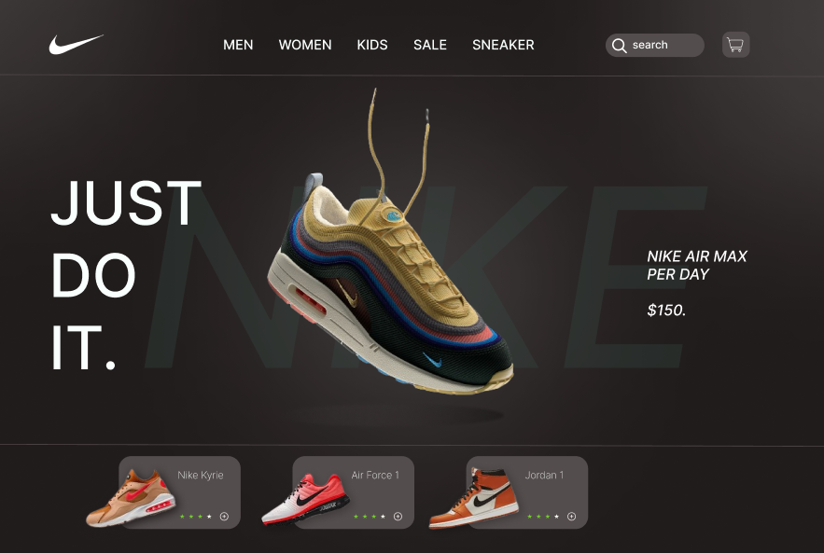

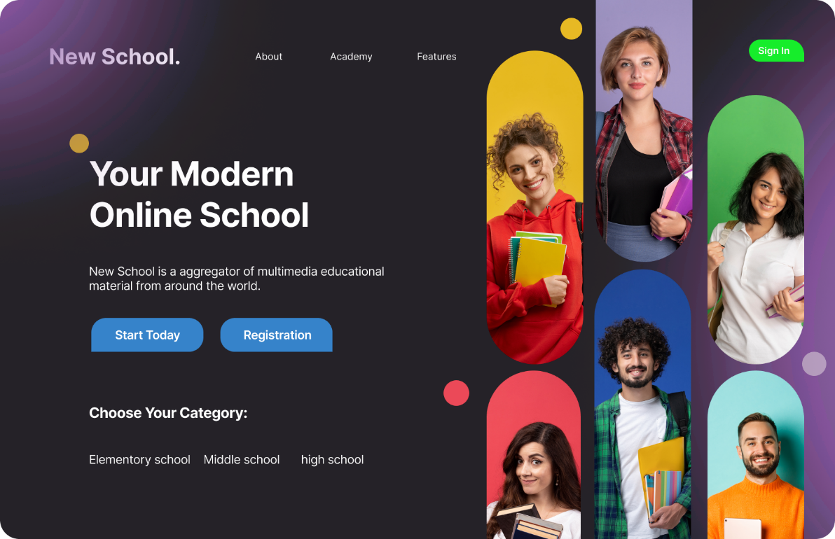

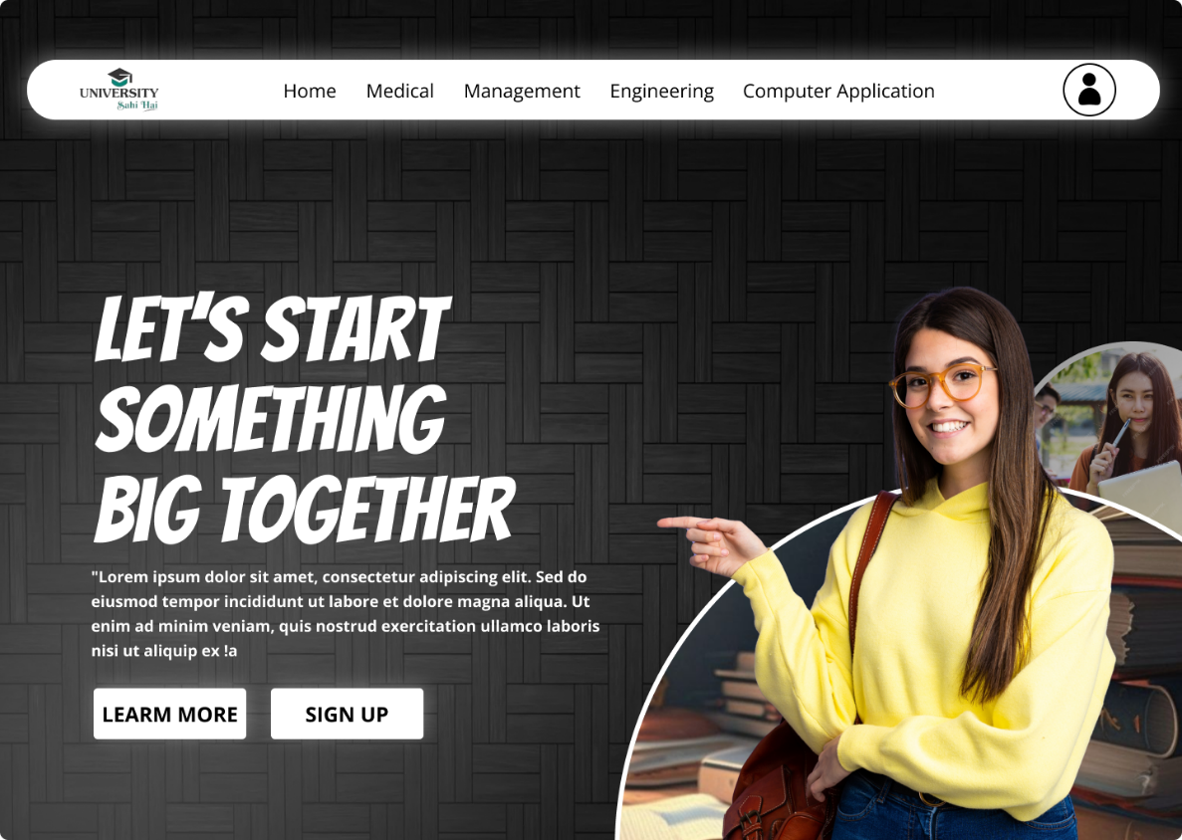

In the Showcased Designs section, I proudly present a curated selection of my creative works, each representing a unique blend of vision, skill, and passion.

**Projects** (Projects)

In this Projects section, I present a diverse range of projects created for practice, showcasing my creativity, problem-solving skills, and dedication to honing my craft. Each project represents an opportunity for growth and learning, illustrating my evolving abilities and passion for design development.

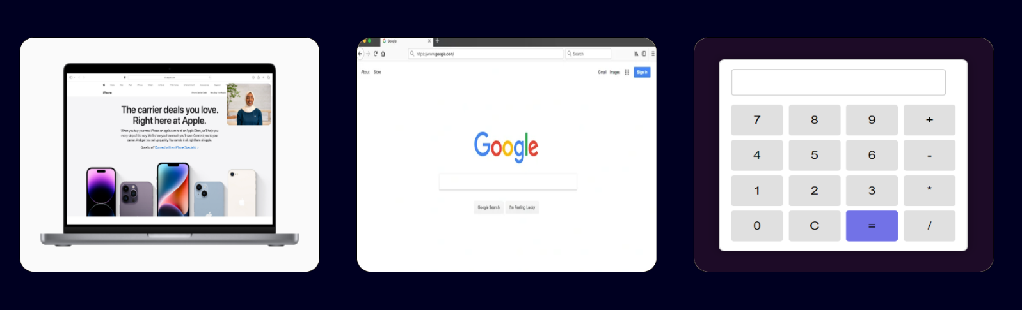

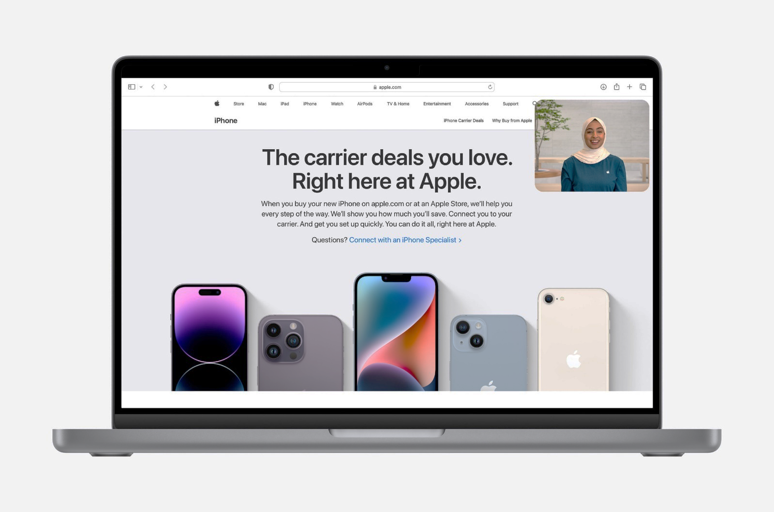

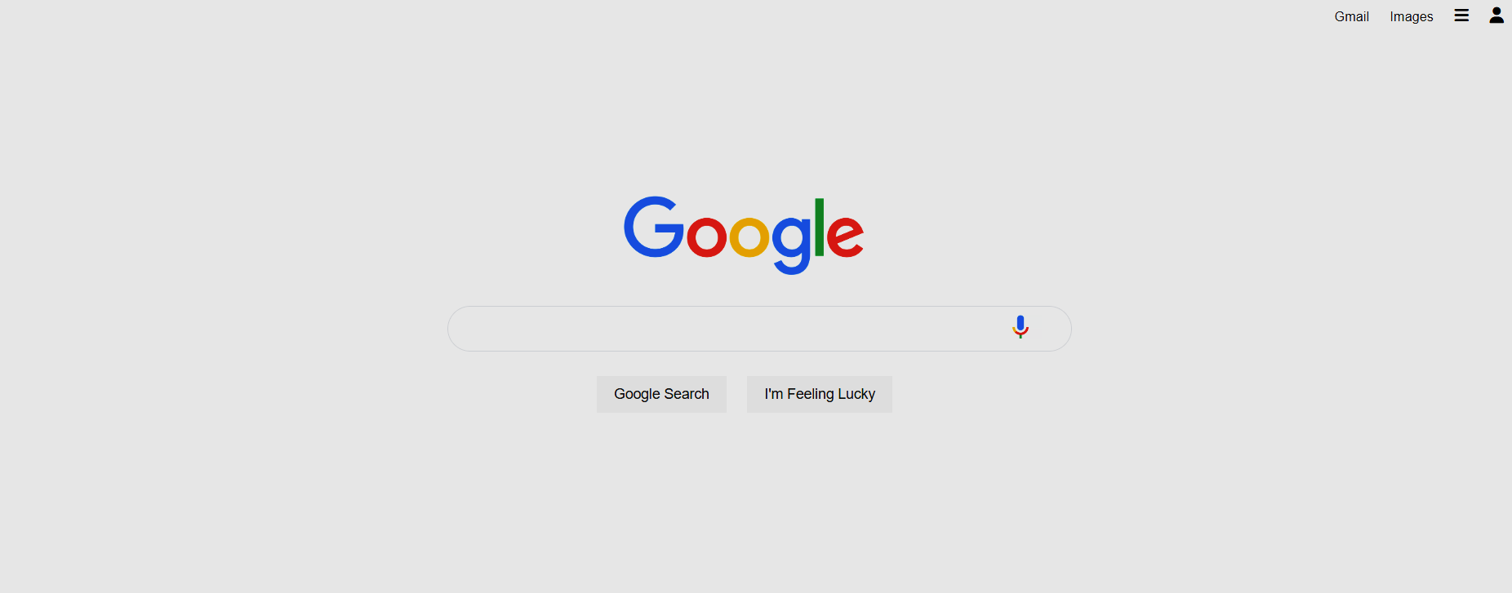

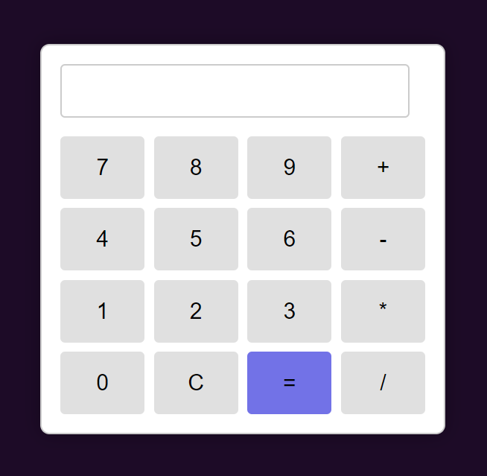

In the Showcased Projects section, I proudly present a curated selection of my creative endeavors, each representing a unique blend of vision, skill, and passion.

**Contact**

In the Contact section, I provide a platform for reaching out, whether through a contact form or an image that visually communicates contact information.

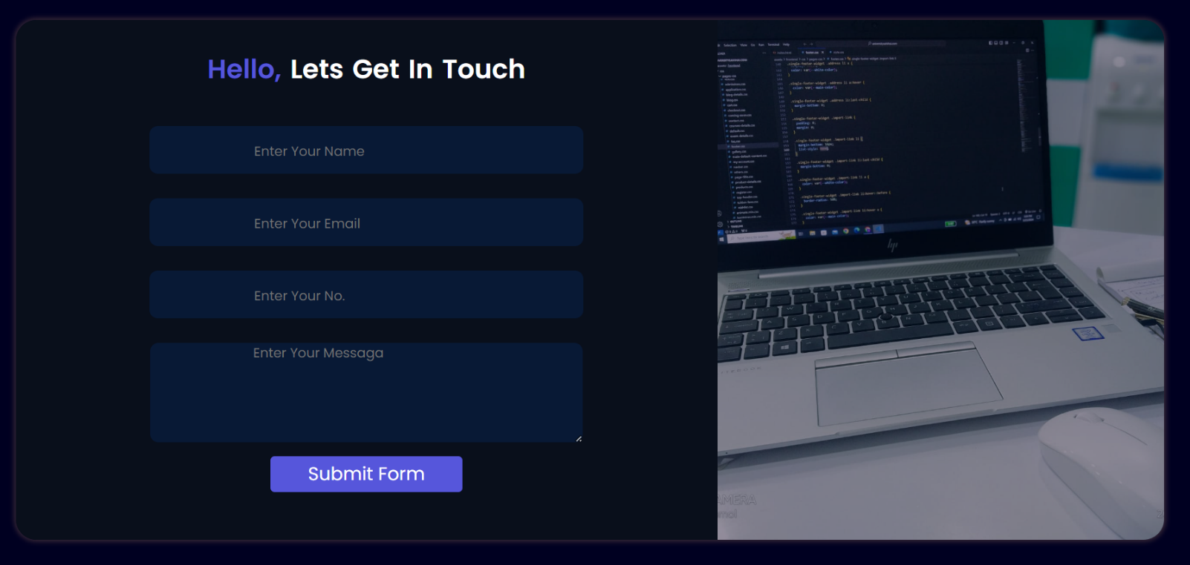

In the Contact section, I proudly showcase a curated selection of my creative endeavors, each representing a unique blend of vision, skill, and passion, ensuring a visually engaging way to get in touch.

**Footer**

Footer Section: At the bottom of the webpage, you'll find copyright information, signaling that all rights are reserved for the content displayed. Unauthorized reproduction or distribution of any material on the site is strictly prohibited.



Button Description: "Back to Top" - This button allows users to swiftly return to the top of the webpage with a single click, facilitating easy navigation.

**Coding Corner: HTML:**

<!DOCTYPE html>

<html lang="en">

<head>

<meta charset="UTF-8">

<meta name="viewport" content="width=device-width, initial-scale=1.0">

<title>My Portfolio</title>

<link href="https://cdn.jsdelivr.net/npm/bootstrap@5.0.2/dist/css/bootstrap.min.css" rel="stylesheet" integrity="sha384-EVSTQN3/azprG1Anm3QDgpJLIm9Nao0Yz1ztcQTwFspd3yD65VohhpuuCOmLASjC" crossorigin="anonymous">

<link rel="stylesheet" href="style.css">

<link rel="preconnect" href="https://fonts.googleapis.com">

<link rel="preconnect" href="https://fonts.gstatic.com" crossorigin>

<link href="https://fonts.googleapis.com/css2?family=Poppins:ital,wght@0,100;0,200;0,300;0,400;0,500;0,600;0,700;0,800;0,900;1,100;1,200;1,300;1,400;1,500;1,600;1,700;1,800;1,900&display=swap" rel="stylesheet">

<!-- Bootstrap CDN -->

</head>

<body>

<!-- header-menu -->

<header>

<nav>

<div class="left-nav">Anmol's <span>Portfolio</span></div>

<div class="right-nav">

<ul>

<li><a href="#home">home</a></li>

<li><a href="#about">about</a></li>

<li><a href="#skills">skills</a></li>

<li><a href="#certificates">certificate</a></li>

<li><a href="#project">projects</a></li>

<li><a href="#contact">contact</a></li>

</ul>

</div>

</nav>

</header>

<!-- main-section -->

<main>

<section id="home">

<div class="left-box">Welcome! <br> I'm Anmol <span>Singh,</span> <br>a friendly <br> <span id="element"></span>

<br><a href="certificates/Anmol frontend Developer resume (2).pdf" target="_blank"><button class="btns">Download Cv</button></a>

<a href="#contact"><button class="btns">Contact Me</button></a>

</div>

<div class="right-box">

<img class="gif-img" src="GXt4.gif" alt=".gif">

<img class="profile-img" src="aboutimage.png" alt=".png">

</div>

</section>

</main>

<!-- about section -->

<div id="about">

<section class="about-section">

<article class="about-text"><img class="about-image" src="aboutimage.png" alt="">Hello! I'm Anmol <span>Singh</span> currently pursuing BCA from Dr. Bhim Rao Ambedkar University. I'm passionate about <span>frontend development, graphics design, and beginner-level UI/UX design</span>. I enjoy creating visually appealing and user-friendly websites and designs.

Throughout my college years, I've worked on various projects to improve my design and coding skills. I've learned a lot and had the chance to create some cool stuff. Check out my portfolio to see my <span>work!.</span></article>

</section>

</div>

<!-- skills-section -->

<div id="skills">

<h1 class="skills-heading">Skills that I know</h1>

<p class="skill-text">"I'm skilled in <span>HTML, CSS,</span> and <span>JavaScript,</span> crafting dynamic web experiences. With <span>Figma,</span> I design intuitive interfaces and prototypes, while <span>Canva</span> helps me create compelling visuals to elevate every project's design."

</p>

<marquee scrollamount="30">

<img src="html-removebg-preview.png" alt="" class="slider">

<img src="css-removebg-preview.png" alt="" class="slider">

<img src="js-removebg-preview.png" alt="" class="slider">

<img src="figma-removebg-preview.png" alt="" class="slider">

<img src="canva-removebg-preview.png" alt="" class="slider">

</marquee>

</div>

<!-- certificates -->

<div id="certificates">

<h1 class="certificate-heading">My Achievements</h1>

<div class="carousel">

<div class="carousel-slide active">

<img src="certificates/html-certificate.png" alt="Image 1">

</div>

<div class="carousel-slide">

<img src="certificates/python certificate.jpg" alt="Image 2">

</div>

<div class="carousel-slide">

<img src="certificates/css-certificate.png" alt="Image 3">

</div>

<div class="carousel-slide">

<img src="certificates/responsive design certificate.jpeg" alt="Image 3">

</div>

<div class="carousel-slide">

<img src="certificates/javascript-certificate.png" alt="Image 3">

</div>

</div>

</div>

<!-- projects -->

<div id="project">

<h1 class="project-heading">project that i made</h1>

<div class="projects">

<div class="box"><a href="nikeshoe.PNG" class="project-show" target="_blank"><img src="nikeshoe.PNG" alt="" class="project-img"></a></div>

<div class="box"><a href="MacBook Pro 16_ - 1.png" class="project-show" target="_blank"><img src="MacBook Pro 16_ - 1.png" alt="" class="project-img"></a></div>

<div class="box"><a href="homepage design (1).png" class="project-show" target="_blank"><img src="homepage design (1).png" alt="" class="project-img"></a></div>

</div>

<div class="projects">

<div class="box"><a href="apple clone/apple clone.html" class="project-show" target="_blank"><img src="Apple-Shop-with-a-Specialist-hero_big.jpg.slideshow-large_2x.jpg" alt="" class="project-img"></a></div>

<div class="box"><a href="googlehome/googlehome.html" class="project-show" target="_blank"><img src="google-homepage_4.webp" alt="" class="project-img"></a></div>

<div class="box"><a href="calculator (1)/todo list/calculator.html" class="project-show" target="_blank"><img src="calculator.PNG" alt="" class="project-img"></a></div>

</div>

</div>

<!-- Contact us page -->

<div id="contact">

<div class="contact-us-box">

<div class="left-contact-box">

<h3 class="contact-heading"><span>hello,</span> lets get in touch</h3>

<form action="https://api.web3forms.com/submit" method="POST">

<input type="hidden" name="access_key" value="10de0615-c2b0-4c30-b540-354d689650c0">

<input type="text" name="name" required placeholder="enter your name"><br>

<input type="email" name="email" required placeholder="enter your email"><br>

<input type="number" name="number" required placeholder="enter your no.">

<br>

<!-- <input class="messaga" type="messaga" name="messaga" required placeholder="enter your message"> -->

<textarea name="messaga" id="messaga" cols="63" rows="5" placeholder=" enter your messaga"></textarea>

<br>

<button type="submit" class="submit-btn">Submit Form</button>

</form>

</div>

<div class="right-contact-box"></div>

</div>

</div>

<!-- footer -->

<footer>

<!-- <a href=" https://wa.me/7302325008" target="_blank"><img class="whatsapp-icon" src="whatsapp-removebg-preview.png" alt=".png"></a> -->

<a href="#home">

<div id="top-btn">

<img class="top-sign" src="top-img-removebg-preview.png" alt=".png">

</div>

</a>

<p class="copyright">Copyright © [Anmol Singh] [2024]. <br>

All rights reserved. Unauthorized reproduction or distribution of any content on this website is prohibited..</p>

</footer>

<script src="https://unpkg.com/typed.js@2.1.0/dist/typed.umd.js"></script>

<script src="https://cdn.jsdelivr.net/npm/bootstrap@5.0.2/dist/js/bootstrap.bundle.min.js" integrity="sha384-MrcW6ZMFYlzcLA8Nl+NtUVF0sA7MsXsP1UyJoMp4YLEuNSfAP+JcXn/tWtIaxVXM" crossorigin="anonymous"></script>

</body>

</html>

**Coding Corner: CSS:**

*{

padding: 0;

margin: 0;

box-sizing: border-box;

}

body{

color: #fff;

background-color: rgb(0, 0, 33);

font-family: "Poppins", sans-serif;

font-weight: 400;

font-style: normal;

}

span{

color: rgb(86, 86, 219);

font-weight: 600;

}

nav{

display: flex;

justify-content: space-around;

align-items: center;

height: 80px;

background-color: rgb(0, 0, 50);

}

nav ul{

display: flex;

justify-content: center;

text-transform: capitalize;

}

nav ul li{

list-style: none;

margin: 0 23px;

}

nav ul li a{

text-decoration: none;

color: #fff;

}

nav ul li a:hover{

color: rgb(77, 77, 180)

}

.left-nav{

font-size: 1.4rem;

font-weight: 500;

}

#home{

display: flex;

justify-content: space-around;

width: 86vw;

height: 70vh;

margin: auto auto;

margin-top: 5%;

margin-bottom: 9%;

}

.left-box{

width: 43vw;

height: 70vh;

font-size: 3.5rem;

font-weight: 500;

padding-top: 5%;

padding-left: 5%;

}

.btns{

color: #fff;

padding: 10px 16px;

outline: none;

border: none;

border-radius: 7px;

font-size: 17px;

margin-left: 15px;

cursor: pointer;

background-color: rgb(93, 93, 185);

-webkit-box-shadow: 1px 1px 10px 1px rgba(0,0,0,1);

-moz-box-shadow: 1px 1px 10px 1px rgba(0,0,0,1);

box-shadow: 1px 1px 10px 1px rgba(0,0,0,1);

}

.btns:hover{

background-color: rgb(35, 35, 93);

}

.right-box{

width: 40vw;

height: 70vh;

margin-left: 10px;

padding-top: 5%;

padding-left: 5%;

}

.profile-img{

height: 80%;

border-radius: 10px;

border-bottom: 3px solid #fff;

z-index: 2;

}

.gif-img{

position: absolute;

height: 50.6%;

mix-blend-mode: multiply;

opacity: 0.2;

z-index: 1;

}

/* about-section */

.about-section{

display: flex;

justify-content: space-around;

width: 86vw;

height: 77vh;

margin: auto auto;

}

.about-text{

font-size: 2.5rem;

font-weight: 520;

word-spacing: 5px;

}

.about-image{

height: 80%;

float: left;

margin-right: 20px;

border-radius: 25px;

opacity: 0.5;

}

/* skills */

#skills{

height: 120vh;

padding-top: 22%;

text-align: center;

}

.skills-heading{

font-size: 4rem;

font-weight: 550;

word-spacing: 5px;

font-style: italic;

text-transform: capitalize;

}

.skill-text{

font-size: 1.6rem;

margin-top: 5%;

}

.slider{

height: 160px;

margin: 0px 30px;

margin-top: 6%;

margin-bottom: 10%;

transition: transform 0.2s ease;

}

.slider:hover{

transform: scale(1.1);

opacity: 0.9;

}

/* certificates */

#certificates{

height: 100vh;

text-align: center;

}

.certificate-heading{

font-size: 4rem;

font-weight: 550;

word-spacing: 5px;

padding-top: 10%;

font-style: italic;

text-transform: capitalize;

}

.carousel {

width: 95%;

overflow: hidden;

position: relative;

padding-top: 3%;

padding-bottom: 5%;

margin: auto auto;

}

.carousel-slide {

display: none;

width: 96%;

height: auto;

margin: auto auto;

}

.carousel-slide.active {

display: block;

}

.carousel-slide img {

width: 100%;

height: 100%;

}

/* projects */

#project{

margin-top: 45%;

height: 100vh;

text-align: center;

}

.project-heading{

font-size: 4rem;

font-weight: 550;

word-spacing: 5px;

font-style: italic;

text-transform: capitalize;

}

.projects{

display: flex;

height: 55vh;

width: 93%;

margin: auto auto;

margin-top: 20px;

}

.box{

border: 1px solid black;

height: 330px;

width: 420px;

margin: auto auto;

border-radius: 20px;

background-color: antiquewhite;

}

.project-img{

height: 100%;

width: 100%;

border-radius: 20px;

}

.project-img:hover{

opacity: 0.8;

}

/* contact us page */

#contact{

height: 90vh;

margin-top: 18%;

}

.contact-us-box{

display: flex;

height: 85vh;

width: 90vw;

margin: auto auto;

border-radius: 25px;

box-shadow: 0px 0px 6px 2px rgba(54,39,54,1);

}

.left-contact-box{

height: 85vh;

width: 55vw;

text-align: center;

border-radius: 25px 0px 0px 25px;

background-color: #090F1B;

}

.contact-heading{

word-spacing: 3px;

margin-top: 40px;

font-size: 2rem;

font-weight: 550;

text-transform: capitalize;

}

form{

position: relative;

text-align: center;

margin-top: 20px;

}

input{

font-size: 3vb;

border: none;

padding: 12px 126px;

background-color: #081935;

border-radius: 10px;

outline: none;

margin-top: 30px;

color: #fff;

text-transform: capitalize;

}

textarea{

border-radius: 10px;

margin-top: 30px;

outline: none;

border: none;

color: #fff;

background-color: #081935;

text-transform: capitalize;

}

::placeholder{

font-size: 1rem;

text-transform: capitalize;

}

.submit-btn{

background-color: rgb(86, 86, 219);

font-size: 3vb;

padding: 5px 45px;

border: none;

border-radius: 5px;

color: #fff;

margin-top: 10px;

}

.right-contact-box{

height: 85vh;

width: 35vw;

border-radius: 0px 25px 25px 0px;

/* background-color: #0F203C; */

background-image: url('contact-image.jpeg');

background-position: center;

background-size: cover;

background-repeat: no-repeat;

opacity: 0.6;

}

/* footer */

footer{

position: relative;

height: 14vh;

text-align: center;

margin-top: 30px;

background-color: #04132d;

}

.copyright{

padding-top: 30px;

/* padding-bottom: 30px; */

}

#top-btn{

position: absolute;

right: 3%;

top: 30%;

width: 45px;

height: 45px;

/* border-radius: 3px; */

background-color: rgb(78, 78, 224);

transition: transform 0.3s ease-in;

}

.top-sign{

height: 25px;

margin: auto auto;

margin-top: 8px;

}

#top-btn:hover{

transform: scale(1.1);

}

.whatsapp-icon{

height: 20px;

}

.whatsapp-icon{

position: absolute;

right: 8%;

top: 30%;

height: 50px;

filter: brightness(110%);

}

**Coding Corner: JAVASCRIPT:**

<script src="https://unpkg.com/typed.js@2.1.0/dist/typed.umd.js"></script>

<script src="https://cdn.jsdelivr.net/npm/bootstrap@5.0.2/dist/js/bootstrap.bundle.min.js" integrity="sha384-MrcW6ZMFYlzcLA8Nl+NtUVF0sA7MsXsP1UyJoMp4YLEuNSfAP+JcXn/tWtIaxVXM" crossorigin="anonymous"></script>

<script>

alert("Are you ready to know about Him?");

var typed = new Typed('#element', {

strings: ['Frontend Developer.', 'Graphics designer.','Post Designer.'],

typeSpeed: 90,

loop:true,

});

document.addEventListener('DOMContentLoaded', function() {

const slides = document.querySelectorAll('.carousel-slide');

let currentIndex = 0;

// Show the first slide initially

slides[currentIndex].classList.add('active');

// Function to show next slide

function showNextSlide() {

slides[currentIndex].classList.remove('active');

currentIndex = (currentIndex + 1) % slides.length;

slides[currentIndex].classList.add('active');

}

// Set interval to change slides every 3 seconds

setInterval(showNextSlide, 3000);

});

</script>